Carlisle Community Choice Aggregation Semi-Annual Report
Q1 - Q4, 2024
Prepared by: Sarah Wasserman, Land Use and Sustainability Coordinator
11 April 2025
Key Points:
- Enrollment saw slight decreases overall but remained stable quarter to quarter.
- Fewer residents saw savings in Q3 and Q4, compared to those not enrolled.
- Fluctuations in the energy market make it difficult to predict potential future savings.
Over the course of the year, the number of meters enrolled in the CCA program stayed relatively static. Both the Standard and Optional Basic pathways saw a minor decrease in participants, while the Optional Green 100 pathway started and ended with the same number of meters registered.
As energy prices have been in flux over the past year, savings were not consistent. In Q3, Eversource Basic Service, which is what non-CCA participants receive, was more competitive than the Standard service option, which is the default for those enrolled. The Standard service option remained more expensive through Q4. The only program pathway that retained savings was the Optional Basic service. Each pathway provides residents with a percentage of their energy from renewable sources. Optional Basic has the least amount of renewable energy, meeting the MA requirement of 24% to 27% Class I RECs (Renewable Energy Certificates).

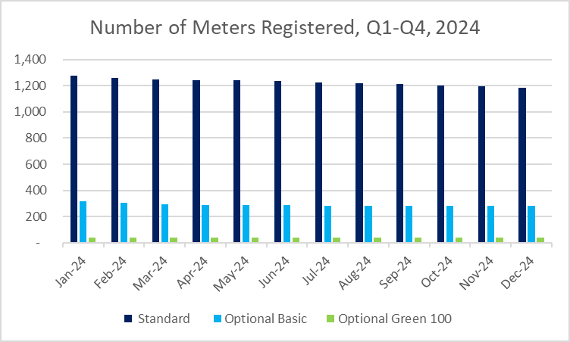

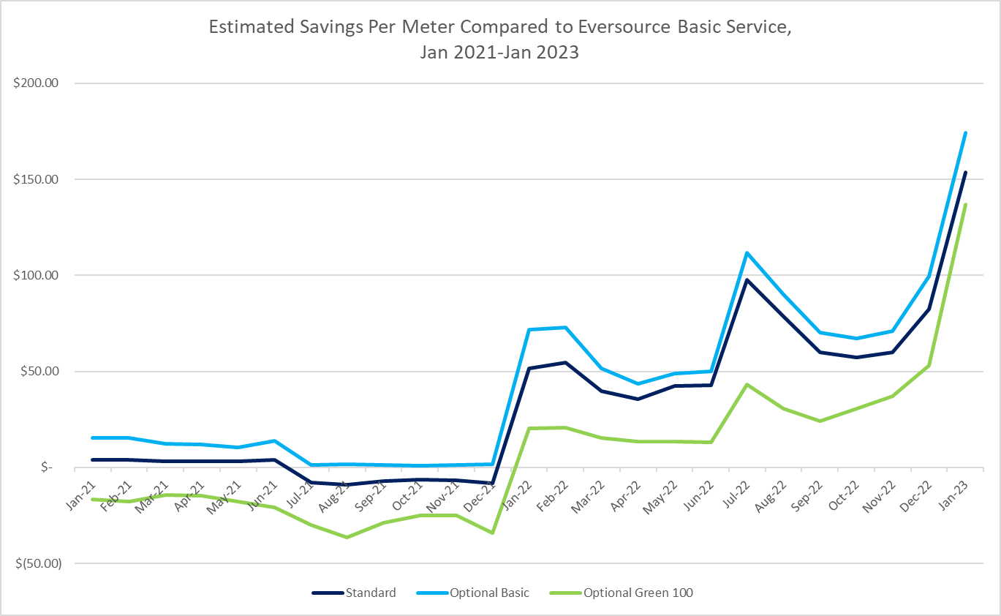
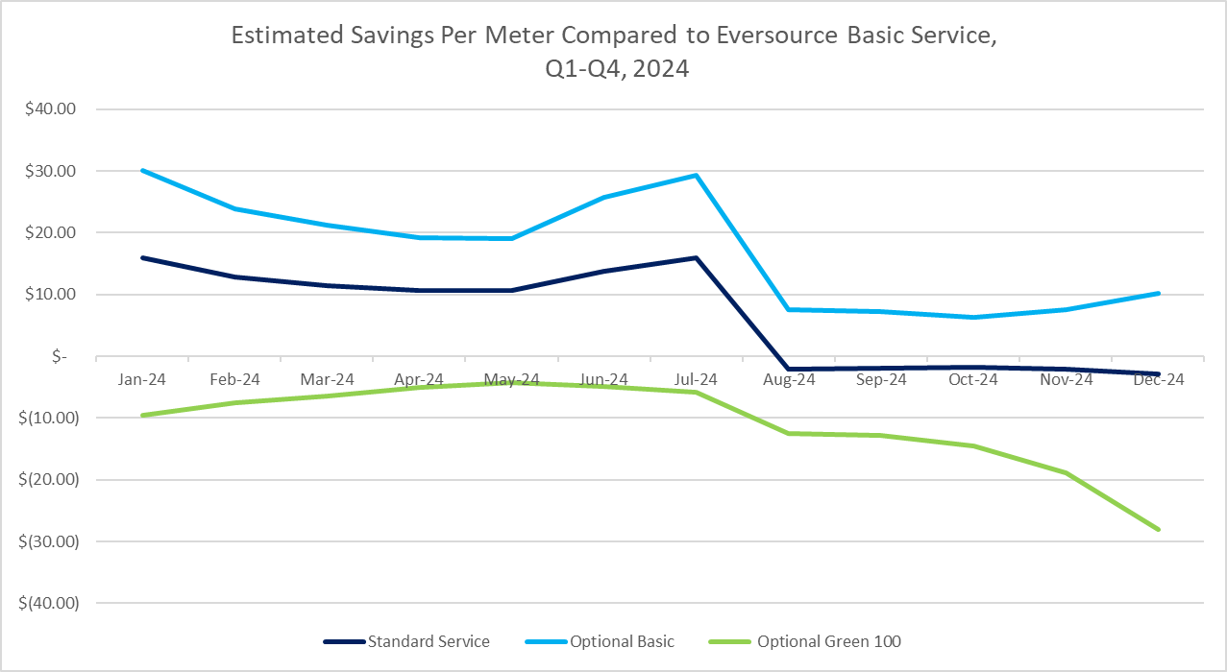
The previous contract cycle, which ran from 2021-2023, benefited from securing the price before energy markets became destabilized in early 2022. The graph below shows how savings shifted within a two-year period during this contract. Savings are not guaranteed through CCA programs, so as the market continues to flux, residents may or may not see savings. The strength of the CCA program is its consistency, as the electricity rates will not change until the end of the contract period.

